**CHARGE - BUDDY**

**A PROJECT REPORT**

**for**

**MINI PROJECT 2 (ID201B)**

**Session (2024-25)**

**Submitted by**

**SHASHANK SINGH**

**202410116100194**

**TARUN KUMAR**

**202410116100223**

**VED TEOTIA**

**202410116100238**

**Submitted in partial fulfillment of the**

**Requirements for the Degree of**

**MASTER OF COMPUTER APPLICATION**

**Under the Supervision of**

**Ms. Shruti Aggarwal**

### Assistant Professor



**Submitted to**

**Department Of Computer Applications**

**KIET Group of Institutions, Ghaziabad**

**Uttar Pradesh-201206**

**(MAY - 2025)**

### CERTIFICATE

Certified that Shashank Singh **202410116100194,** Tarun Kumar **202410116100223** and Ved Teotia **202410116100238** have carried out the project work having “**CHARGE - BUDDY**” (**Mini Project-II, ID201B**) for **Master of Computer Application** from Dr. A.P.J. Abdul Kalam Technical University (AKTU**)** (formerly UPTU), Lucknow under my supervision. The project report embodies original work, and studies are carried out by the students herself and the contents of the project report do not form the basis for the award of any other degree to the candidate or to anybody else from this or any other University/Institution.

**Ms. Shruti Aggarwal Dr. Akash Rajak**

**Assistant Professor Dean**

**Department of Computer Applications Department of Computer Applications**

**KIET Group of Institutions, Ghaziabad KIET Group of Institutions, Ghaziabad**

**CHARGE - BUDDY**

**ABSTRACT**

This project report explores the development of Charge-Buddy, an intelligent EV charging station locator app, conceptualized as a mini-project aimed at delivering accessible, scalable, and user-friendly support for electric vehicle (EV) users. In an era where electric mobility is rapidly expanding, many users still face challenges related to limited charging infrastructure, inconsistent availability, and lack of real-time information. Charge-Buddy addresses these issues by providing smart, location-based charging assistance to EV drivers, helping them plan routes, locate nearby stations, and reserve charging slots seamlessly.

The application leverages the power of geolocation services, real-time databases, and intuitive user interfaces to offer a streamlined experience for users. It includes features such as real-time station availability, booking capabilities, trip-based recommendations, and filter options based on charger type and compatibility. Designed for web and mobile platforms, Charge-Buddy ensures accessibility for a wide demographic, including those in remote or underserved areas with growing EV adoption.

This report provides a detailed analysis of the project's feasibility from technical, financial, and social perspectives. The implementation plan highlights the use of technologies such as Python, Firebase, and Google Maps API to build an efficient and interactive system. It also considers the integration of secure user authentication and personalized dashboards to enhance the user experience and data security.

Beyond the technical execution, this project emphasizes its potential environmental and social impact by supporting the EV ecosystem and promoting sustainable transportation. By offering a reliable and user-centric tool for EV charging management, Charge-Buddy aims to reduce range anxiety, encourage EV usage, and contribute to broader goals of reducing carbon emissions and fostering green mobility.

### ACKNOWLEDGEMENTS

Success in life is never attained single-handedly. My deepest gratitude goes to my project supervisor, **Ms. Shruti Aggarwal** for her guidance, help, and encouragement throughout my project work. Their enlightening ideas, comments, and suggestions.

Words are not enough to express my gratitude to **Dr. Akash Rajak**, Professor and Dean, Department of Computer Applications, for his insightful comments and administrative help on various occasions.

Fortunately, I have many understanding friends, who have helped me a lot on many critical conditions.

Finally, my sincere thanks go to my family members and all those who have directly and indirectly provided me with moral support and other kind of help. Without their support, completion of this work would not have been possible in time. They keep my life filled with enjoyment and happiness.

**Shashank Singh**

**Tarun Kumar**

**Ved Teotia**

### TABLE OF CONTENTS

|  |  |  |  |
| --- | --- | --- | --- |
|  | Certificate | | ii |
|  | Abstract | | iii |
|  | Acknowledgment | | iv |
|  | Table of Contents | | v |
| 1 | Introduction | | 1-4 |
|  | 1.1 | Overview | 1 |
|  | 1.2 | Objective | 2 |
|  | 1.3 | Project Scope | 3 |
|  | 1.4 | Project Description | 4 |
|  | 1.5 | Purpose | 4 |
| 2 | Feasibility Study | | 5-7 |
|  | 2.1 | Market Analysis | 5 |
|  | 2.2 | Technical Feasibility | 5 |
|  | 2.3 | Operational Feasibility | 6 |
|  | 2.4 | Financial Feasibility | 6 |
|  | 2.5 | Legal and Ethical Consideration | 7 |
|  | 2.6 Recommendation | | 7 |
| 3 | Project Objective | | 8-9 |
| 4 | Hardware and Software Requirements | | 10-11 |
| 5 | Project Flow | | 12-25 |
| 6 | Project Outcome | | 26-32 |
| 7 | Reference | | 33-36 |
|  |  | |  |
|  |  | |  |
|  |  | |  |
|  |  | |  |

### CHAPTER 1

### INTRODUCTION

**1.1 Overview**

As electric vehicles (EVs) become increasingly popular due to environmental concerns and the push for sustainable transportation, the demand for accessible and efficient EV charging infrastructure has grown significantly. One of the primary challenges for EV users is locating nearby charging stations and securing available slots, especially during peak hours or in underserved regions.

Technological advancements now enable digital solutions to streamline the EV charging experience. **Charge-Buddy** is a user-centric application designed to bridge the gap between EV drivers and charging infrastructure by helping users locate nearby EV charging stations, check availability, and book charging slots in real-time. This scalable, accessible platform enhances the overall EV ownership experience.

**1.2 Objectives**

· **Introduction to the Charge-Buddy Concept**:  
To introduce the Charge-Buddy app, its purpose in addressing challenges faced by EV owners, and its role in improving access to EV charging stations.

· **Assessment of the Need for EV Charging Apps**:  
To explore the growing demand for efficient EV infrastructure navigation tools, the limitations of current systems, and the value of a centralized booking platform.

· **Identifying Key Features and Functionalities**:  
To outline the primary features of Charge-Buddy, such as station discovery, real-time availability, slot booking, route planning, and payment integration.

· **Exploration of Technology and Tools Used**:  
To explain the technologies (e.g., geolocation services, mapping APIs, real-time databases) used in building and operating the application, as well as considerations for performance, scalability, and user data privacy.

· **Benefits and Limitations of Using Charge-Buddy**:  
To evaluate how the app improves accessibility, efficiency, and user satisfaction, while acknowledging challenges such as coverage limitations and reliance on station data accuracy.

· **Effectiveness of EV Charging Platforms**:  
To examine existing research and feedback on digital EV charging tools and to discuss the effectiveness of real-time booking systems in reducing wait times and enhancing planning.

· **Personalization and User Experience**:  
To highlight the importance of personalized station suggestions, user preferences, and a seamless booking flow that caters to different EV models and user routines.

· **Ethical Considerations**:  
To address user data security, location tracking, and transparency in terms of availability and pricing. To consider inclusivity and equitable access to EV infrastructure.

· **Challenges in Implementing Charge-Buddy**:  
To discuss technical, regulatory, and adoption-related challenges, including integration with diverse station networks and ensuring reliable real-time data.

· **Future Directions and Enhancements**:  
To propose enhancements such as smart routing, integration with vehicle systems, predictive analytics for station usage, and expanding the database of supported stations.

· **1.3 Project Scope: Charge-Buddy – EV Charging Station Locator**

**Core Features**

a) **Station Locator**:  
Real-time map interface to display nearby EV charging stations based on the user’s current location or destination. Filters by station type, charging speed, and connector type.

b) **Slot Booking**:  
Ability to reserve a charging slot at a preferred time. Displays station availability and estimated wait times.

c) **Route Planning**:  
Suggests optimal routes with charging stops along the way, considering the vehicle’s battery level and range.

d) **Personalized Recommendations**:  
Offers suggestions for frequently used stations, preferred times, and historical usage data.

**1.3.2 Technology Stack**

a) **Geolocation and Mapping Services**:  
Utilizes GPS and APIs like Google Maps or OpenStreetMap to locate stations and plan routes.

b) **Real-time Database Integration**:  
Backend systems to fetch live data on station availability and manage booking slots dynamically.

c) **Mobile and Web App Development**:  
Cross-platform support using frameworks like React Native, Flutter, or standard web technologies.

d) **Privacy & Data Security**:  
Complies with data protection laws and ensures secure handling of location and booking data.

**1.3.3 User Experience (UX) and Interface**

a) **Intuitive Navigation**:  
User-friendly layout with interactive maps, clear booking steps, and instant confirmations.

b) **Cross-Platform Accessibility**:  
Accessible via mobile apps (Android, iOS) and web portals.

c) **Customizable User Settings**:  
Users can manage vehicle profiles, set charging reminders, save favorite stations, and receive push notifications.

**1.3.4 Optional Advanced Features**

a) **Emergency Station Locator**:  
Suggests the nearest available charging station if the battery is critically low.

b) **In-App Usage Tracking**:  
Logs charging history, costs, and energy usage trends for user review.

c) **Integration with Charging Networks**:  
Partners with EV charging providers to enable in-app payments and loyalty rewards.

**1.4 Project Description**

Charge-Buddy is a smart, real-time application designed to assist EV owners in navigating the charging landscape. By offering a centralized platform for discovering, booking, and managing EV charging sessions, Charge-Buddy simplifies the EV experience through the integration of modern technologies and a user-first design.

**Functionalities -**

**Real-Time Station Discovery:**

Displays live data on nearby charging points and station status.

**Booking and Scheduling:**

Allows users to reserve slots, minimizing wait times and ensuring availability.

**Secure Transactions:**

Handles bookings and payments securely with encrypted communications.

**24/7 Availability:**

Operates round the clock to support EV users whenever they need to charge.

**1.5 Purpose**

The primary goal of Charge-Buddy is to support the growing EV ecosystem by solving accessibility and usability challenges in charging infrastructure. It aims to:

### **Promote Sustainable Transportation:**

### By facilitating seamless EV charging, Charge-Buddy encourages wider EV adoption.

### **Enhance Infrastructure Utilization:**

### Optimizes usage of existing charging stations through real-time bookings and intelligent routing.

### **Improve User Convenience:**

### Reduces range anxiety by offering reliable, user-friendly access to charging stations.

### **Support a Greener Future:**

### Helps reduce emissions by making EVs more viable and user-friendly.

### CHAPTER-2

### FEASIBILITY STUDY

**Introduction**

As electric vehicles (EVs) gain popularity, one of the most pressing challenges for drivers is the accessibility and reliability of charging infrastructure. Many EV users struggle with finding available charging stations, planning long trips, or booking slots in advance. Charge-Buddy is designed to solve these issues through an intelligent platform that enables real-time station discovery, slot reservations, and optimized route planning.

**2.1 Market Analysis**

* Target Audience:
  + EV owners in urban and semi-urban areas.
  + Fleet operators, delivery services, and taxi aggregators using EVs.
  + Early EV adopters in underserved or rural regions with limited charging infrastructure.
* Market Demand:
  + Rapid growth in EV adoption due to environmental policies and rising fuel prices.
  + Increasing need for efficient, real-time information on EV charging stations.
  + Demand for convenience in planning charging sessions during commutes or long journeys.

· Competitor Analysis:

* + Existing apps like PlugShare, ChargePoint, and A Better Routeplanner offer station listings and reviews.
  + Charge-Buddy differentiates through a simplified UI, real-time slot booking, localized station info, and possible integration with public/private charging providers.

**2.2 Technical Feasibility**

* **Technology Stack:**

· **Frontend:** Web and mobile app interfaces using React Native or Flutter.

· **Backend:** REST APIs with Node.js or Python; real-time data through Firebase or AWS Amplify.

· **APIs and Integrations:** Google Maps API, OpenChargeMap API, station provider APIs for availability data.

· **Database:** Firestore or PostgreSQL for user data, preferences, and booking logs.

* **Core Features:**
  + Map-based station locator with filters (charger type, availability).
  + Booking engine for reserving charging slots.
  + Route planning with charging stops based on vehicle range.
* **Challenges:**
  + Securing real-time data access from a wide range of station networks.
  + Ensuring high reliability in areas with inconsistent internet connectivity.

**2.3 Operational Feasibility**

* **Human Resource Requirements:**
  + 2–3 developers for frontend, backend, and mobile platforms.
  + 1 project/product manager for coordination.
  + 1 support executive during beta testing and post-launch.
  + Optional: Partnership manager to onboard new charging networks.
* **Workflow:**
  + Phase 1: Build MVP with core locator and booking functionality.
  + Phase 2: Pilot deployment in a limited region (e.g., one city or a university campus with EV infrastructure).
  + Phase 3: Integrate user feedback, add more stations, expand coverage.
* **Risks and Mitigation:**
  + Risk: Limited user engagement.
    - Mitigation: Easy-to-use interface and gamified interactions.
  + Risk: Over-reliance on chatbot for serious mental health issues.
    - Mitigation: Clear disclaimers and escalation mechanisms.

**2.4 Financial Feasibility**

* **Cost Estimation:**
  + Development: $7,000 – $12,000 (app and backend infrastructure).
  + Hosting & APIs: $800 – $1,500/year for cloud services and map APIs.
  + Maintenance & Updates: $2,000/year for technical support and feature improvements.

**2.5 Legal and Ethical Considerations**

* **Data Privacy:**
  + Store only essential, non-sensitive user data (e.g., location preferences, charging history).
  + Use encrypted communications and comply with data protection laws (GDPR, local equivalents).
* **Liability and Disclaimer:**
  + Clear disclaimer about third-party data (e.g., availability or pricing at stations may vary).
* **Bias and Inclusivity:**
  + Incorporate user feedback from diverse regions and demographics.

**2.6 Recommendations**

* Start with a working prototype focused on EV station location and booking using existing APIs.
* Launch a pilot version in a specific city or region with growing EV usage.
* Refine the app using real-time user feedback and performance metrics.
* Develop partnerships with charging station providers, municipalities, and vehicle manufacturers to scale network integration and reach..

### CHAPTER 3

### PROJECT OBJECTIVE

1. **Key Objectives**
2. **Enhancing Accessibility to EV Charging Infrastructure**
   * Provide a digital-first solution that ensures round-the-clock access to information on available EV charging stations.
   * Address common challenges such as lack of real-time availability, long wait times, and difficulty locating charging stations in specific regions.
3. **Promoting EV Awareness and Efficient Charging Habits**
   * Educate users about different types of chargers, optimal charging times, and energy-efficient driving behaviors.
   * Encourage the adoption of electric vehicles by improving infrastructure visibility and user confidence.
4. **Delivering Personalized and Scalable Services**
   * Leverage AI and data analytics to offer tailored station recommendations based on user preferences, location, and travel patterns.
   * Ensure the solution scales to support a growing EV user base across urban, suburban, and rural areas.
5. **Ensuring User Privacy and Data Security**
   * Adhere to global privacy standards like GDPR and local regulations.
   * Ensure secure data handling for location, preferences, and booking information with encrypted communication channels.
6. **Project Objectives**
7. **Development of the EV Charging Platform**
   * Design and implement an intuitive application that helps users locate nearby EV charging stations and book available slots in real-time.
   * Integrate core features such as map-based navigation, station filtering, slot booking, and usage history tracking.
8. **User-Centric Design and Experience**
   * Create a responsive, easy-to-use interface for both web and mobile platforms with a focus on minimal interaction for maximum output.
   * Include customizable settings such as favorite station lists, booking reminders, and preferred charger types to enhance user convenience.
9. **Integration of Advanced Technologies**
   * Utilize APIs and GPS technology to provide accurate, up-to-date charging station data.
   * Implement AI-based recommendations for optimal charging routes based on current battery level, destination, and traffic data.
10. **Scalability and Multi-Platform Deployment**
    * Deploy the application on multiple platforms including iOS, Android, and web browsers to ensure wide accessibility.
    * Ensure backend systems support a large number of concurrent users with minimal latency.
11. **Future-Proofing and Continuous Improvement**
    * Build the system with a modular and extensible architecture to support future enhancements like in-app payments, real-time charging status updates, and integration with vehicle infotainment systems.
    * Regularly gather and analyze anonymized user feedback to refine functionalities and improve satisfaction over time.

### CHAPTER 4

### HARDWARE AND SOFTWARE REQUIREMENTS

1. **Hardware Requirements**
2. **Development Environment**
   * Processor: i5/i7 for smoother execution.
   * RAM: At least 8 GB
   * Storage : 20-50 GB free space for installing libraries , frameworks, and storing logs or datasets.
   * Graphics : Not mandatory, but a basic GPU can assist in map rendering and front-end performance testing.
3. **Internet Connection:**
   * A stable and fast internet connection for downloading the pre-trained model, libraries, and deployment dependencies.
4. **Optional Devices:**
   * GPS-Enabled Device: For testing location-based features.
   * External storage for backups.
5. **Software Requirements**

**1. Operating System**

* Windows 10/11.
* Linux is preferred for better compatibility.

**2. Programming Language and Environment**

* JavaScript, Python (3.8 or higher) — for backend services and location-based logic.
* Text Editor : VS Code for coding and debugging.

**3. Frameworks and Libraries**

* Flask :
* For creating the web application.
* PyTorch:
* Required for loading and running the pre-trained DialoGPT model.
* Install using pip install torch.
* Transformers :
* Used for the DialoGPT model and tokenizer.
* Install using pip install transformers.
* Bootstrap:
* For frontend styling and responsive design.
* Included through CDN links in your HTML.
* jQuery:
* For handling dynamic frontend interactions
* Font Awesome:
* For icons used in your chatbot interface.
* HTML/CSS:
* Used for structuring and styling the frontend.

**4. Browser Compatibility**

* Modern browsers like Google Chrome and Edge for testing and running the chatbot interface.

**5. Database**

* MySQL for structured data.

**6. APIs and Integrations**

* Google Maps Platform: For station location, directions, and geolocation.
* EV Station API (where available) for live slot availability and booking.
* Payment Gateway Integration (optional for future enhancements).-

**7. Hosting and Deployment**

* Local Development:
* Flask's built-in server for running the app locally.
* Cloud Deployment:

### CHAPTER-5

### PROJECT FLOW

1. **Project Planning & Research**

* **Objective:** Lay a solid foundation for the Charge-Buddy chatbot project by identifying goals, user needs, and feasibility.
* **Tasks:**
  + **Market Research:** Analyze existing EV charging assistant apps and chatbots. Study their strengths, weaknesses, and user feedback. **Outcome**: A comparison matrix highlighting gaps and innovation opportunities for Charge-Buddy.
  + **Target Audience Analysis**: Identify key users – EV owners, fleet managers, or first-time EV users. **Outcome:** User personas detailing demographics, charging behavior, pain points, and preferred platforms..
  + **Needs Assessment:** Determine whether the chatbot will provide station location, charger status, booking, trip planning, etc. **Outcome:** A clear feature list that aligns with user needs..
  + **Scope Definition:** Define what Charge-Buddy will and will not do (e.g., not performing transactions). **Outcome:** Scope document to guide development.

**Compliance & Regulations:** Research data policies (e.g., GDPR, CCPA) relevant to location tracking and user data. **Outcome:** Privacy and compliance checklist.

1. **Requirements Gathering**

* **Objective:** Detail the specific features and functional requirements.
* **Tasks:**

**Create User Personas:** Develop representative personas (e.g., city EV owner, rural fleet driver).

**Outcome:** Detailed user profiles to inform design and interactions..

* + **Define Core Features:**
    - Locate nearby charging stations.
    - Show charger availability and type (fast/slow).
    - Plan routes with charging stops.
    - Push notifications for charger status.
    - Booking or reservation (if supported).

**Outcome:** Core features document..

**Platform Selection:** Decide on platforms (web app, mobile app, integration with Google Maps or WhatsApp).

**Outcome:** Deployment strategy documents.

* + **Security & Privacy:** Define what user/location data is collected and how consent is obtained.

**Outcome**: Data policy for transparency and trust.

1. **Design Phase**

* **Objective:** Define UI, UX, conversation flow, and integration strategies.
* **Tasks:**
  + **User Experience Design:**
    - Responsive design for mobile/web.
    - Easy-to-use interface with minimal input.

**Outcome:** Wireframes and UI mockups.

* + **Conversation Flow:**
    - * Greet user → Get current location → Show nearest stations → Provide ETA/booking options → Handle follow-ups.
      * **Outcome:** Conversational flow diagrams.
  + **Map & Data Integration:**
    - Integrate real-time map APIs (e.g., Google Maps, OpenChargeMap).
    - **Outcome:** Integration plan with dynamic data handling.
  + **Chatbot Persona Design:**
    - Friendly, helpful, and non-technical assistant style (e.g., "Hey! Need to top up your battery?").
    - **Outcome:** Persona guidelines.
  + **Feedback Collections:**
    - Users can rate suggestions, report wrong data, or suggest improvements.
    - **Outcome:** In-chat feedback collection system.

1. **Development Phase**

* Objective: Build the chatbot according to the designs and specifications.
* Tasks:
  + **NLP Model Development:**
    - Use libraries like Rasa or Dialogflow to identify user intents (e.g., “find charger”, “check availability”).
  + **Data Integration:**
    - Real-time charger status via APIs; charger type, cost, and ETA.
  + **Route Planning AI:**
    - Suggest stations based on battery level, trip distance, traffic.
  + **Backend System Development:**
    - Store session logs, preferences, anonymous user data.
  + **Cross-Platform Compatibility:**
    - Ensure similar functionality on web and mobile.
  + **Privacy Safeguards:**
    - Encrypt user locations; obtain explicit consent for GPS use.

1. **Testing Phase**

* **Objective:** Ensure Charge-Buddy runs smoothly and securely.
* **Tasks:**
  + **Functional Testing:**
    - Test all workflows: location input, station suggestions, bookings, errors.
  + **Usability Testing:**
    - Observe real users; evaluate ease of use, clarity of responses.
  + **Security & Privacy Testing:**
    - Ensure no sensitive data leaks; test API limits and fail-safes.
  + **Performance Testing:**
    - Simulate high traffic to assess server load handling.

1. **Launch Phase**

* **Objective:** Deploy Charge-Buddy and initiate user engagement.
* **Tasks:**
  + **Soft Launch:**
    - Consider a beta release to a limited user group to gather initial feedback and make final adjustments.
  + **Public Launch:**
    - Deploy to app stores or web with full marketing support

.

* + **User Onboarding:**
    - Quick start tutorial, GPS permission guide, FAQs.
  + **Monitoring:**
    - Set up logs and dashboards for errors, usage, and feedback.

1. **Maintenance & Updates**

* Objective: Continuously evolve the platform based on usage.
* Tasks:
  + Bug Fixes:
    - Address technical or data inaccuracies.
  + Feature Updates:
    - Add new features like charger reviews, loyalty points, or EV community features.
  + User Feedback Loop:
    - Regular surveys and feature request options.
  + Content Updates:
    - Add support for new charger networks and stations.

1. **Reporting & Evaluation**

* **Objective:** Measure Charge-Buddy's impact and usage.
* **Tasks:**
  + **Engagement Metrics:**
    - Number of sessions, common queries, charger bookings.
  + **User Feedback:**
    - Ratings and improvement suggestions.
  + **Data Trends:**
    - Popular charger types, regions with high demand.
  + **Impact Report:**
    - Evaluate if it reduces user anxiety over charger availability.

### Entities and Their Attributes

* **User**
* UserID, Name, Email, VehicleType, RegistrationDate
* **ChatSession**
* SessionID, UserID, StartTime, EndTime
* **Message**
* MessageID, SessionID, Sender, Timestamp, Content
* **FeedbackEntry**
* FeedbackID, UserID, SessionID, Rating, Comments, SubmissionDate
* **ChargerLocation**
* ChargerID, Location, ChargerType, Status, Cost, Operator
* **KnowledgeBase**
* EntryID, Topic, Content

**Relationships:**

* One-to-Many: User → ChatSession, ChatSession → Message, User → FeedbackEntry
* One-to-One: ChatSession ↔ FeedbackEntry
* Many-to-One: Message → KnowledgeBase

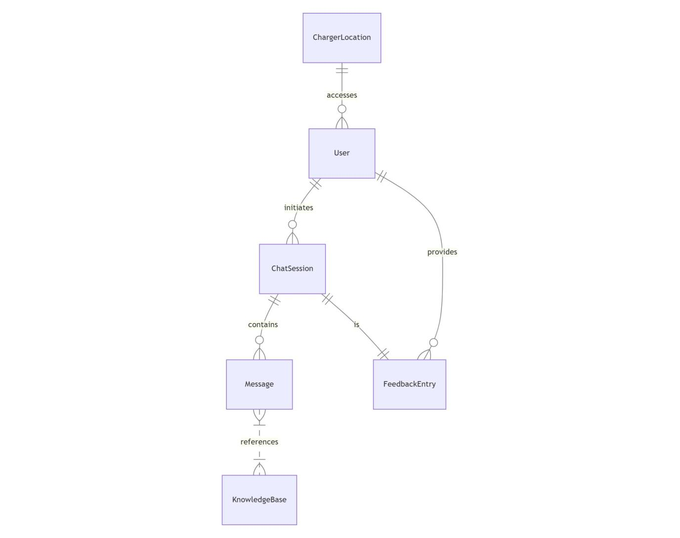

Fig. 5.1 E-R Diagram

1. **DFDs**

**DFD Level 0 (Context Diagram)**

**External Entity:** User

**System:** Charge-Buddy

**Flow:** User inputs → Chatbot processes → Outputs suggestions → Collects feedback

**DFD Level 1**

**Processes:** Start Chat, Process Input, Show Stations, Plan Route, Store Data, Collect Feedback

**Data Stores:** User Data, Charger Info, Session Logs, Feedback

**DFD Level 2**

Each sub-process broken into validation, API calls, route calculations, feedback analysis.

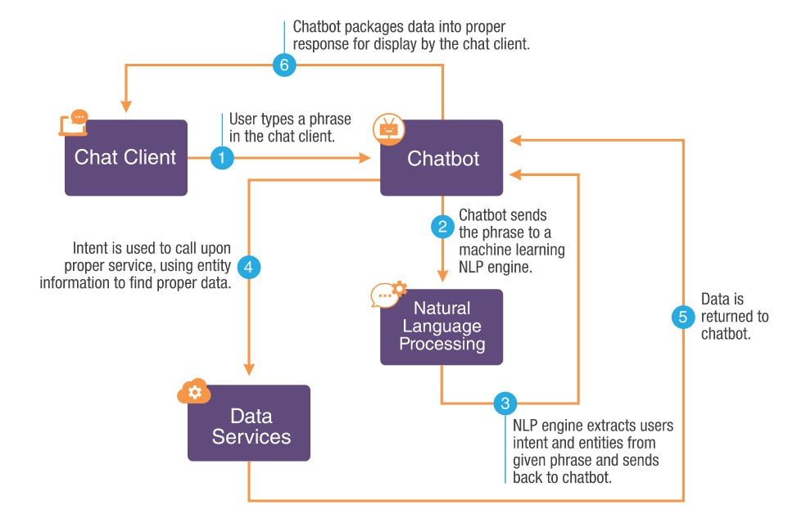

Fig 5.2 DFD

### CHAPTER-6

### PROJECT OUTCOME

### Improved Access to EV Charging Infrastructure

* **Description:** Charge-Buddy offers 24/7 access to real-time charging station information, allowing users to locate, check availability, and book slots at nearby EV charging stations instantly. It reduces the complexity and stress of finding a charging point, especially in unfamiliar or underserved areas.
* **Outcome:** Increased access to EV charging stations, particularly in regions where infrastructure is sparse. The app’s secure login and personalized dashboard enhance user trust while making the process seamless and user-specific.

1. **Personalized Route Planning and Booking**

* **Description**: The app offers route planning based on the user’s current battery level, preferred stations, and travel destination. It adapts suggestions based on user behavior and preferences, ensuring efficient trip planning.
* **Outcome:** Improved travel efficiency and user satisfaction due to fewer detours and optimized charging routes. Personalized recommendations reduce range anxiety and streamline the EV charging experience.

1. **Enhanced Awareness of Charging Options and Station Types**

* **Description:** Through the app, users learn about different charger types, connector compatibilities, and station networks. Educational tooltips and filter options help EV owners make informed decisions.
* **Outcome:** Better user knowledge and confidence in using the EV charging ecosystem. The app promotes awareness and adoption of green transport by demystifying charging processes.

1. **Increased User Engagement and Satisfaction**

* **Description:** Charge-Buddy’s clean UI, intuitive navigation, and features like favorites, notifications, and history tracking make it highly engaging. The ability to reserve charging slots ahead of time boosts reliability and user trust.
* **Outcome:** High engagement rates and returning users who find the app reliable and convenient for everyday travel needs. This leads to higher satisfaction and advocacy among EV users.

1. **Data-Driven Insights for Infrastructure Improvement**

* **Description:** Usage patterns, station ratings, and booking history provide valuable analytics for identifying high-demand areas or underused stations. These insights can help charging providers optimize network placement.
* **Outcome:** Enhanced planning for EV infrastructure deployment and smarter energy resource allocation based on real-world usage data collected (with full user consent and anonymization).

1. **Scalability and Platform Expansion**

* **Description:** The app is designed to scale easily and can be deployed on Android, iOS, and the web. It can also integrate with navigation systems and car OS in the future.
* **Outcome:** A broader user base across urban and rural areas, with the potential to integrate with vehicle dashboards, fleet management systems, or government EV initiatives.

1. **Positive Impact on EV Adoption and Sustainability**

* **Description:** By simplifying the charging experience and providing real-time support, Charge-Buddy helps address one of the biggest barriers to EV adoption—range and charging anxiety.
* **Outcome:** Encourages more people to transition to electric vehicles, contributing to reduced carbon emissions and promoting eco-friendly transportation habits

.

1. **Ethical Data Handling and Privacy Compliance**

* **Description:** The app adheres to data privacy regulations like GDPR, ensuring that user location, booking, and personal data are securely stored and used only with consent.
* **Outcome:** Builds trust among users, encouraging more open and consistent use of the app while ensuring that sensitive data is never misused or exposed.

1. **Insights for Future Development**

* **Description:** The app development lifecycle includes user feedback loops, allowing the team to refine UI, fix issues, and introduce new features like predictive availability or AI-based suggestions.
* **Outcome:** A continually improving product that evolves with user needs, ensuring long-term relevance and effectiveness in the rapidly growing EV market.

1. **Recognition as a Viable EV Ecosystem Tool**

* **Description:** With consistent performance and user satisfaction, Charge-Buddy can be recognized by automotive companies, charging providers, and public transport planners as a vital part of the EV ecosystem.
* **Outcome:** Potential integration into smart city platforms, national EV infrastructure strategies, or in-car systems, amplifying its impact and reach.

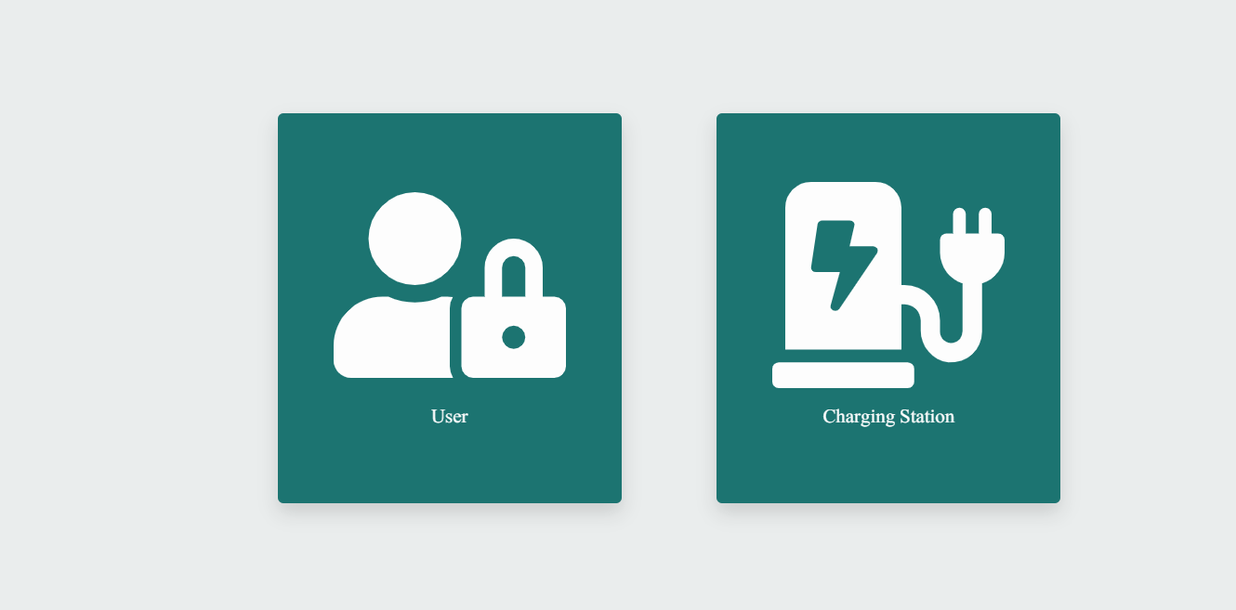

Fig 6.1



Fig 6.2

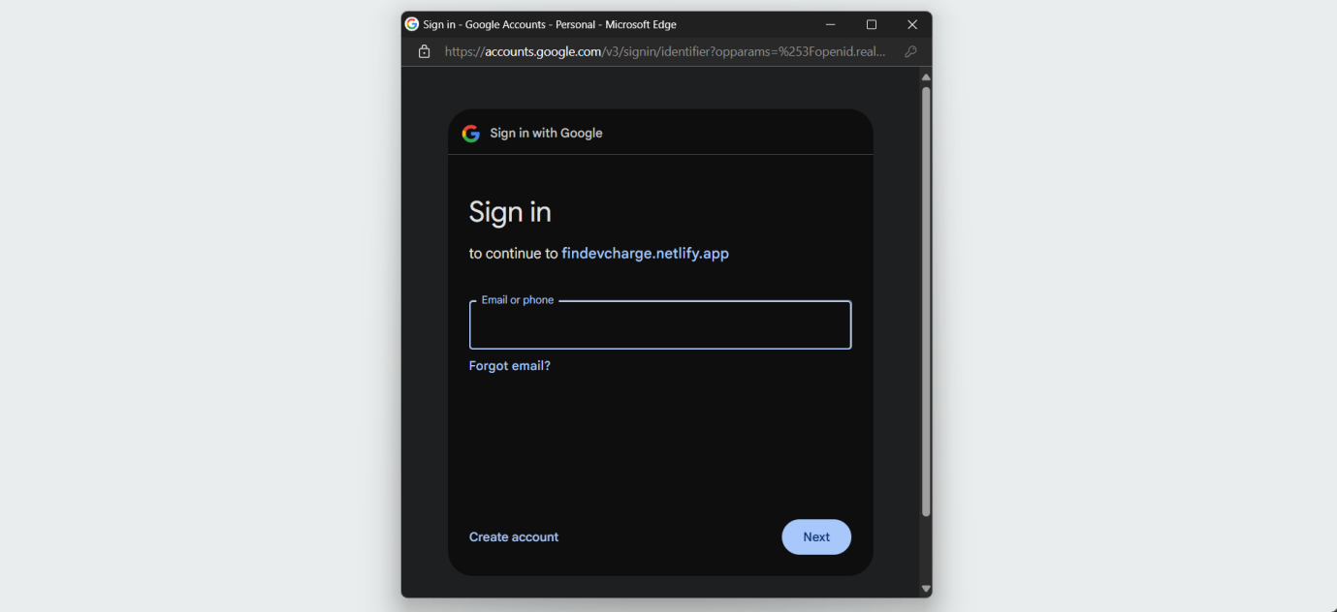

Fig 6.3

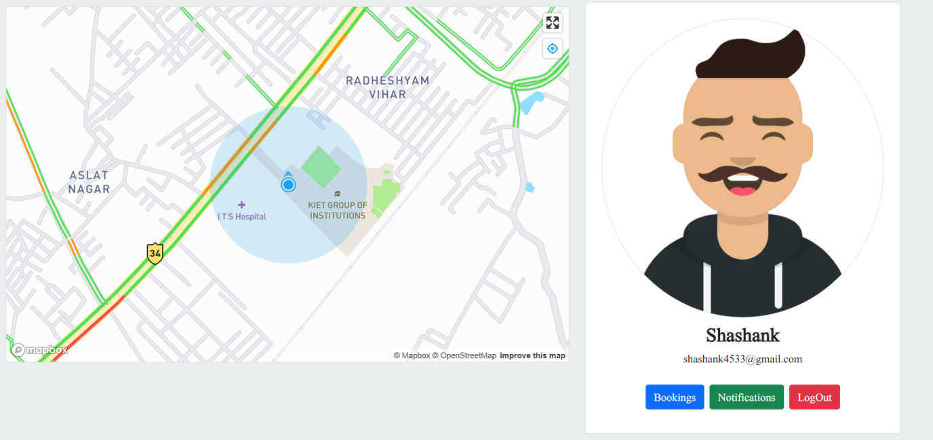

Fig 6.4

### Screenshot 2025-05-06 090555

Fig 6.6

### REFERENCES

**Books**

· **"Electric Vehicle Integration into Modern Power Networks" by Rodrigo Garcia-Valle and João A. Peças Lopes**  
– This book provides an in-depth analysis of the integration of EVs with power grids, offering insights into charging infrastructure and energy management strategies essential for applications like Charge-Buddy.

· **"Smart Grid: Fundamentals of Design and Analysis" by James Momoh**  
– A foundational text for understanding smart grid technologies and their relevance to EV infrastructure planning and real-time data utilization in applications such as EV charging locators.

1. · **"The Electric Vehicle Conversion Handbook" by Mark Warner**  
   – Though focused on vehicle conversion, this book discusses EV operation, charging methods, and practical aspects that inform user requirements and infrastructure needs for Charge-Buddy development.

· **Research Papers and Articles**

1. **Neaimeh, M., et al. (2015). "A probabilistic approach to combining smart charging and smart grid technologies for electric vehicles." Energy Policy.**  
   – Explores intelligent charging strategies and how EV applications can help balance grid demands while optimizing charger availability.
2. **Nicholas, M. A., & Hall, D. (2018). "Lessons Learned on Early Electric Vehicle Fast-Charging Deployments." International Council on Clean Transportation.**  
   – Reviews early EV fast-charging infrastructure deployment, offering valuable lessons for platforms like Charge-Buddy on siting and user expectations.
3. **Hardman, S., et al. (2017). "A review of consumer preferences of and interactions with electric vehicle charging infrastructure." Transportation Research Part D.**

– Discusses user behavior and preferences, which can directly inform Charge-Buddy's UX design and features like charger filtering and booking.

1. **Wolbertus, R., et al. (2018). "An assessment of public charging infrastructure use in the Netherlands: A data-driven approach." World Electric Vehicle Journal.**  
   – Provides data-driven insights into real-world usage of public EV chargers, helping applications like Charge-Buddy make evidence-based feature decisions.

**Online Articles & Reports**

· **"Mapping the Future of EV Charging Infrastructure" (2023), McKinsey & Company**  
– Highlights key trends, gaps, and innovations in EV charging, providing valuable context for Charge-Buddy’s scalability and development direction.

· **"Electric Vehicle Outlook 2024", BloombergNEF**  
– A comprehensive report projecting EV adoption trends and infrastructure growth, supporting strategic decisions for scaling Charge-Buddy.

· **"How Real-Time Data Is Transforming EV Charging Networks", GreenBiz (2022)**  
– Explains the importance of real-time data and how apps like Charge-Buddy benefit from live updates on station availability.